**Project 3 Part 2 (intermediary recursive approach)**

Name: Aditya Vasantharao Period: 3

Date: 10/29/21

Is your lab name l032?(lowercase L followed by digits 032) Yes

Did you created a class to store a point? Yes

Did you use a vector to store the points you generated? Yes

Did you use at least one iterator to traverse the vector you created? Yes

Does your main contain only 2 calls of: part1() and part2() + writing to the results.txt? Yes

Paste here a clear picture of the content of the results.txt file in 2 random runs:

Run 1:

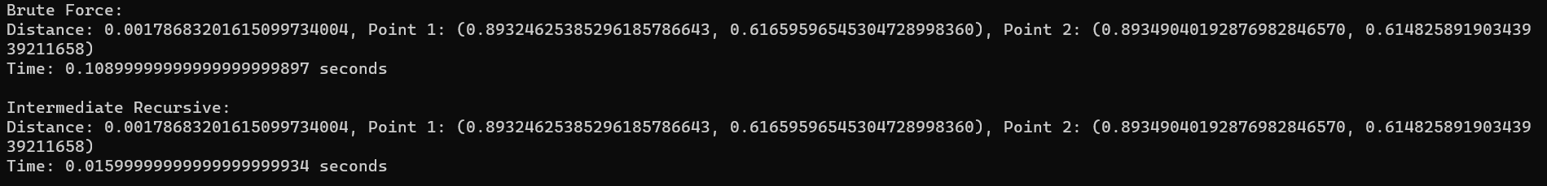

Run 2:

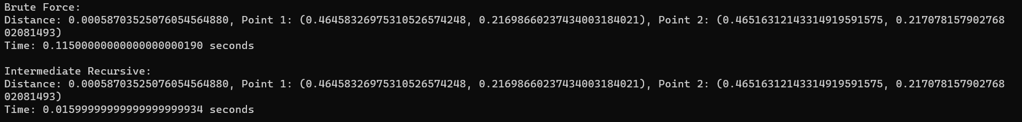

Paste here a clear picture of the graph that compares the running times of the two algorithms versus number of points. (use 2 different colors for the 2 graphs):

Graph:

